Name:K.Manoj Kumar
regno:23MIS0159

TASK 1: Jenkins Familiarization Objective:
Understand Jenkins UI and basic navigation
Tasks:
1. Open Jenkins Dashboard in browser
2. Identify:
o Dashboard
o Manage Jenkins
o New Item
o Build History
3. Check Jenkins version
Expected Output:
• Screenshot or note of Jenkins version
DASHBOARD,Jenkins Version:

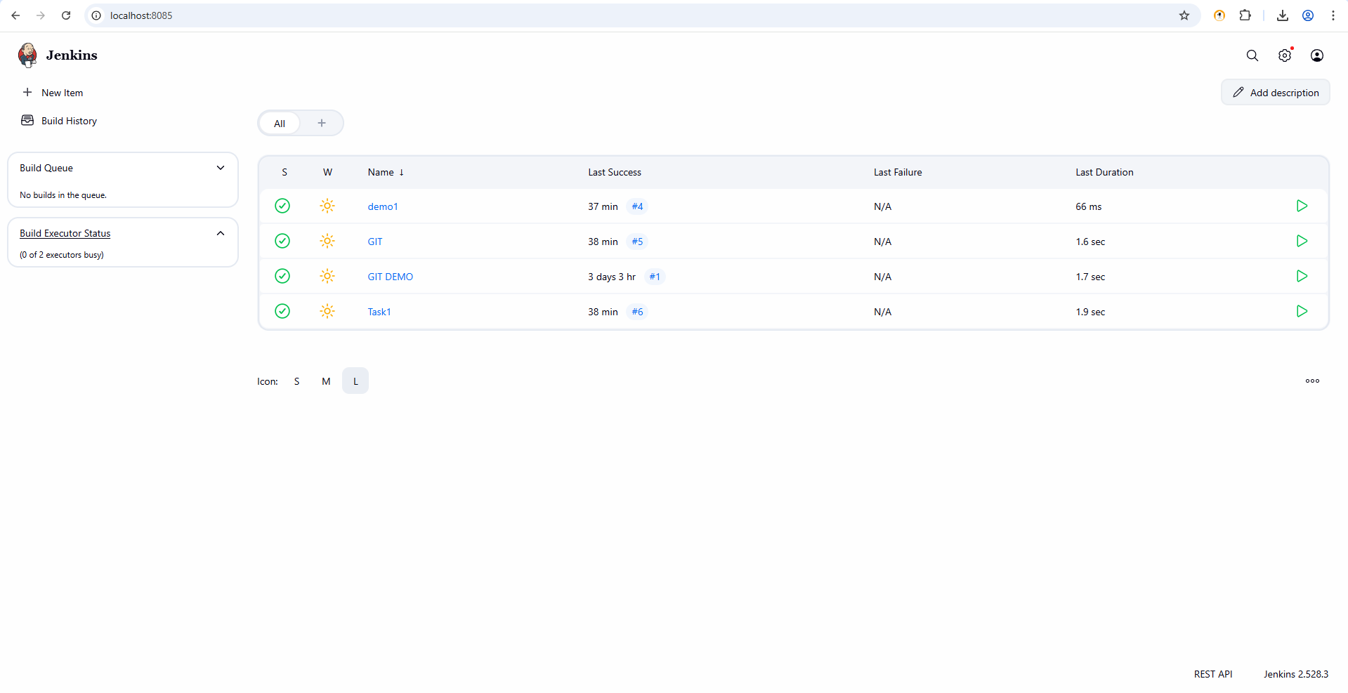
NEWITEMS:
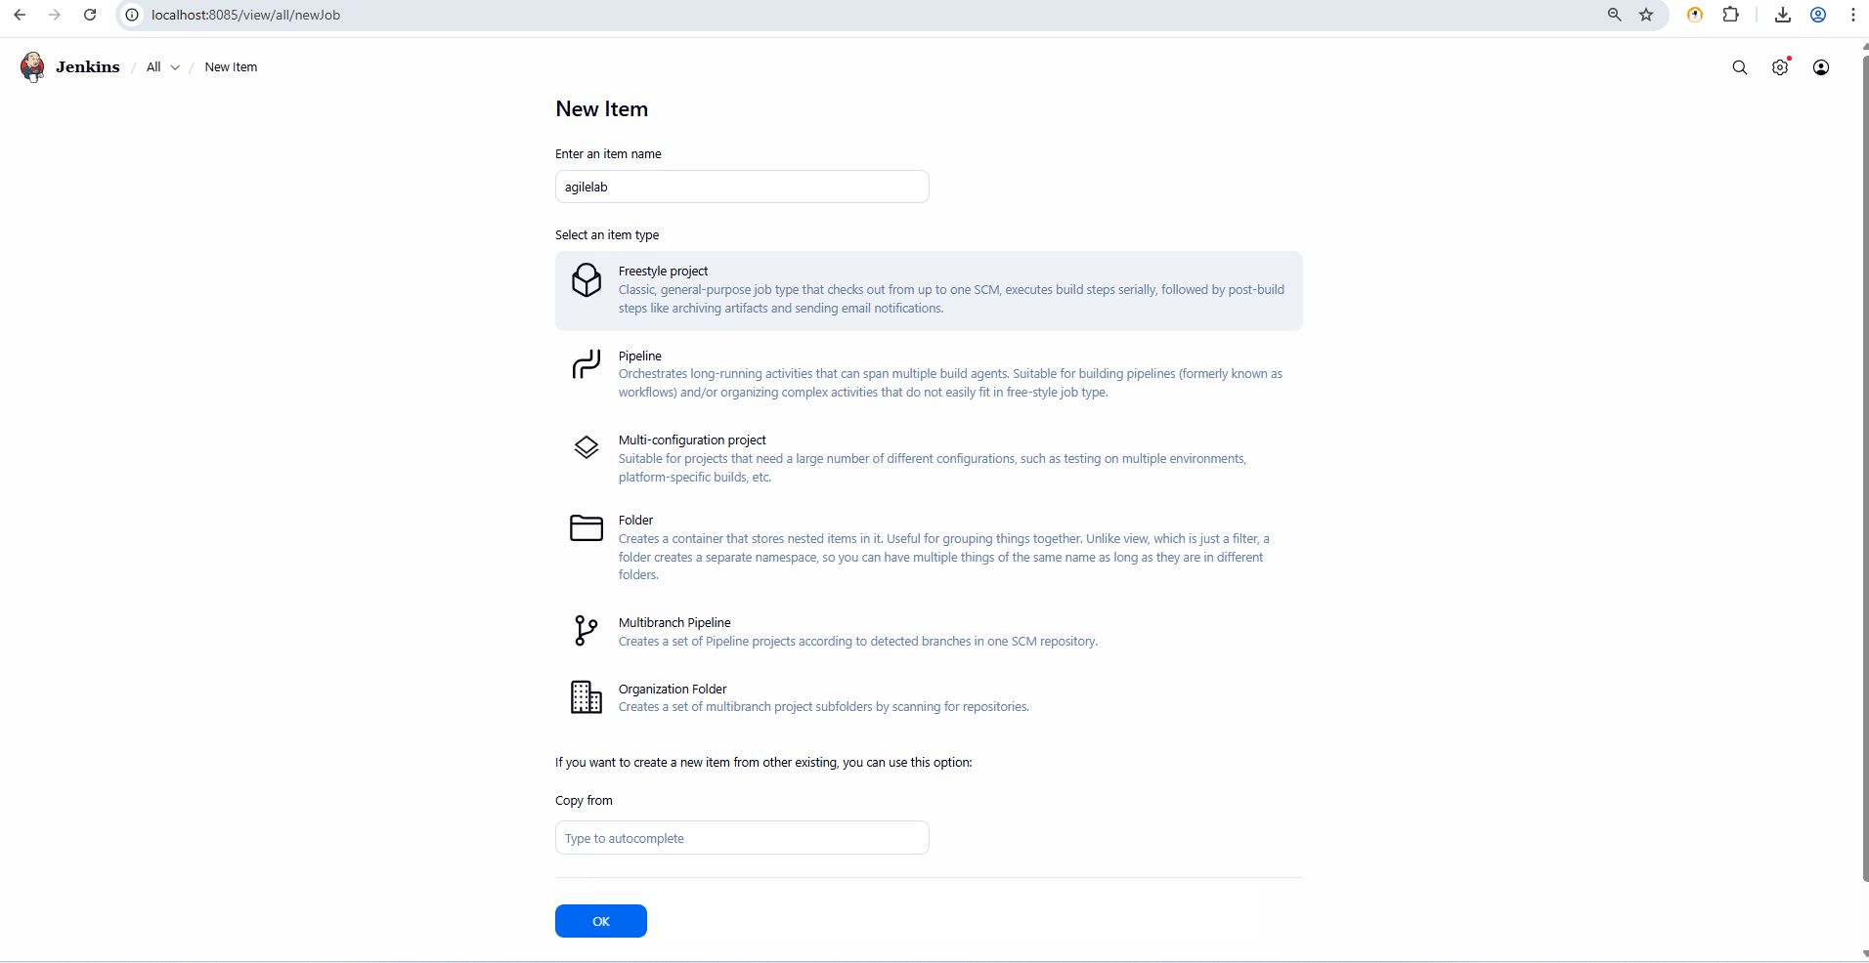
Build History:
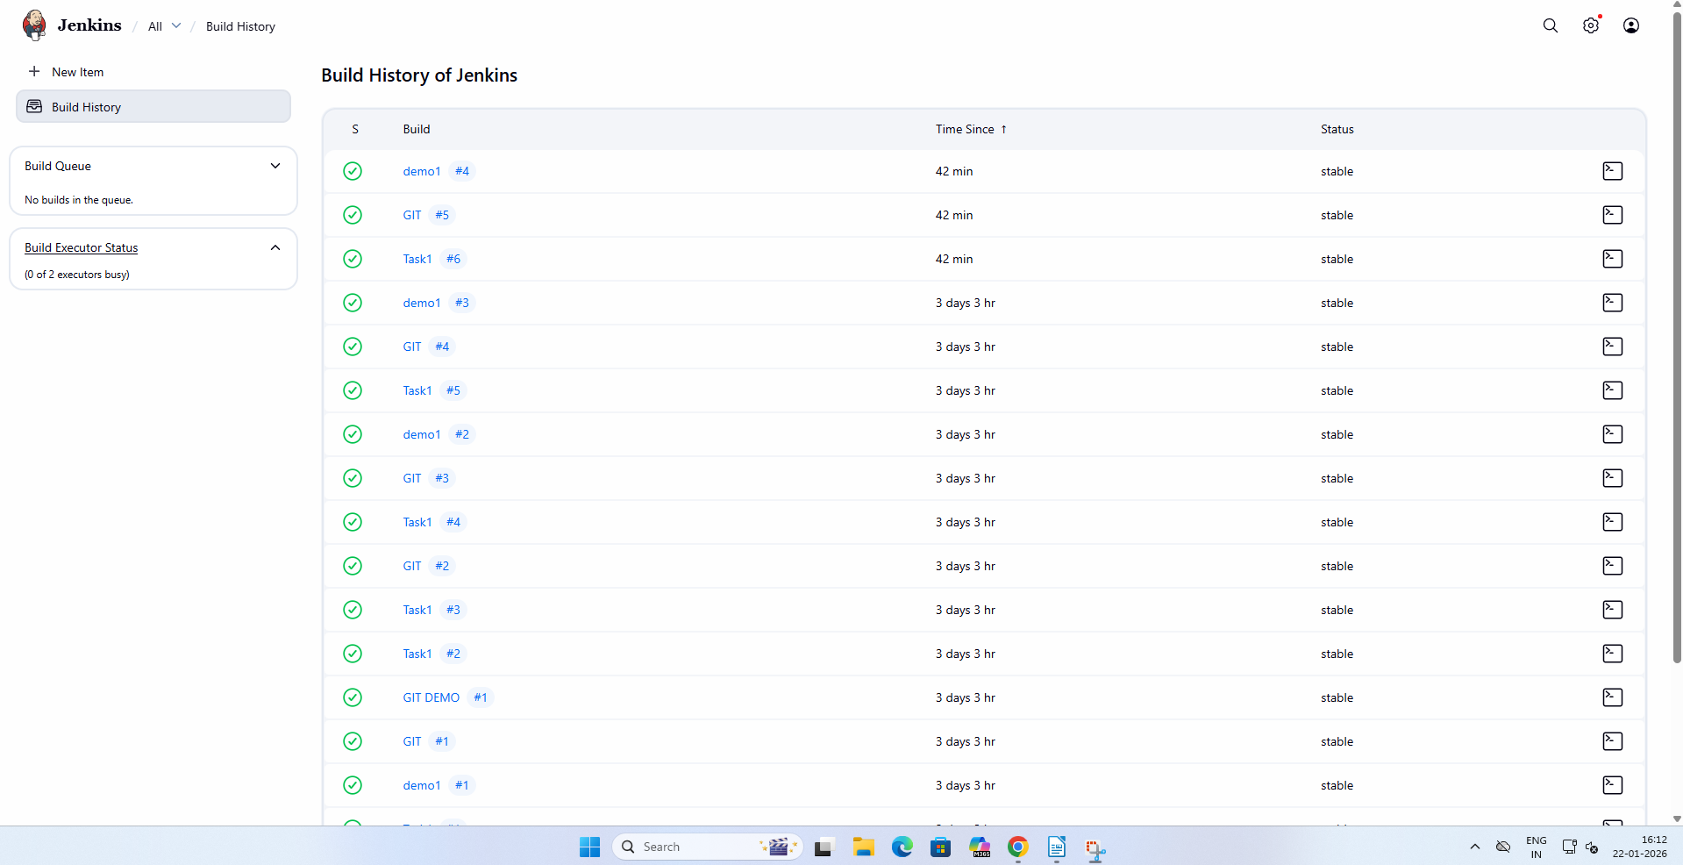
MANAGE JENKINS:
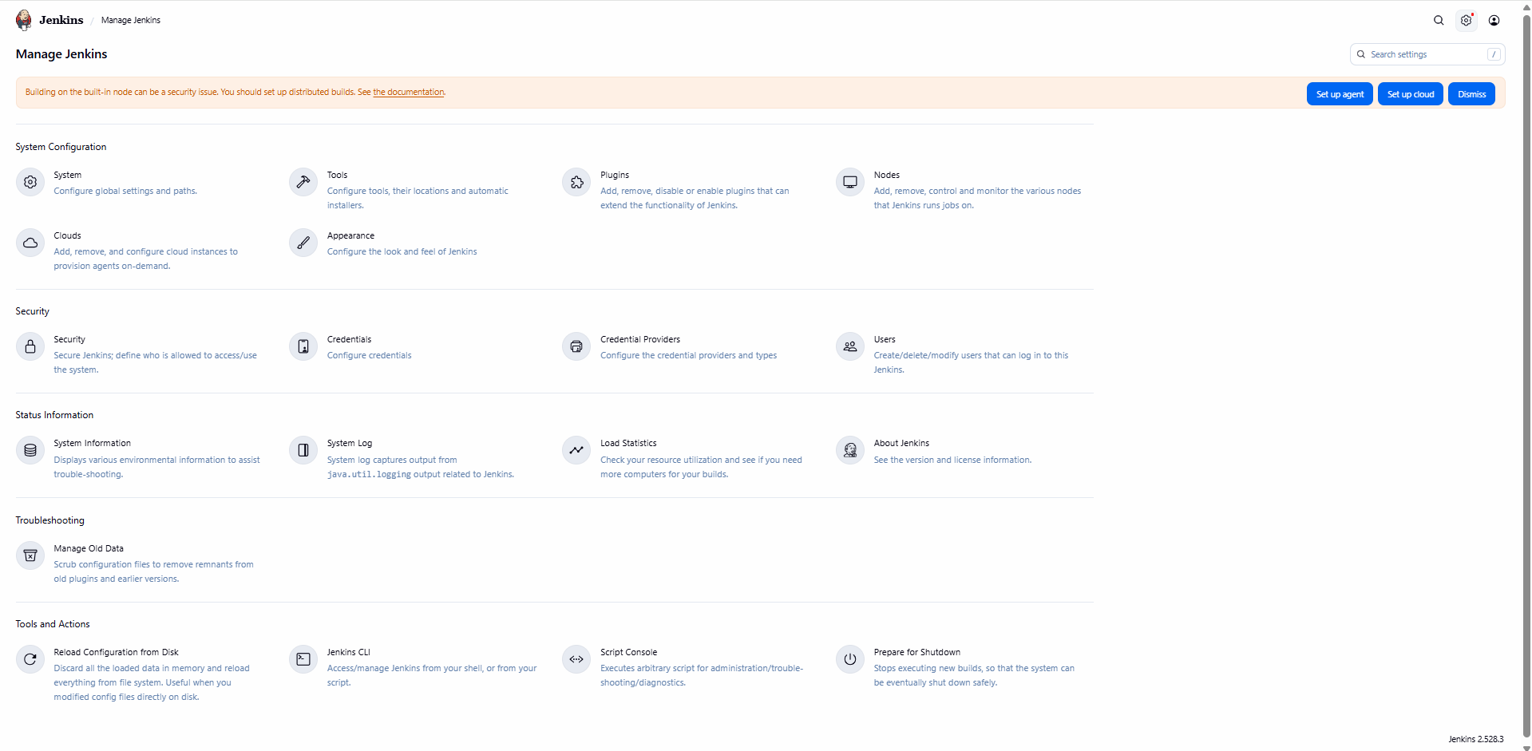

TASK 2: Create First Freestyle Job
Objective:
Create and run a Jenkins job
Tasks:
1. Create a Freestyle project named Hello-Jenkins
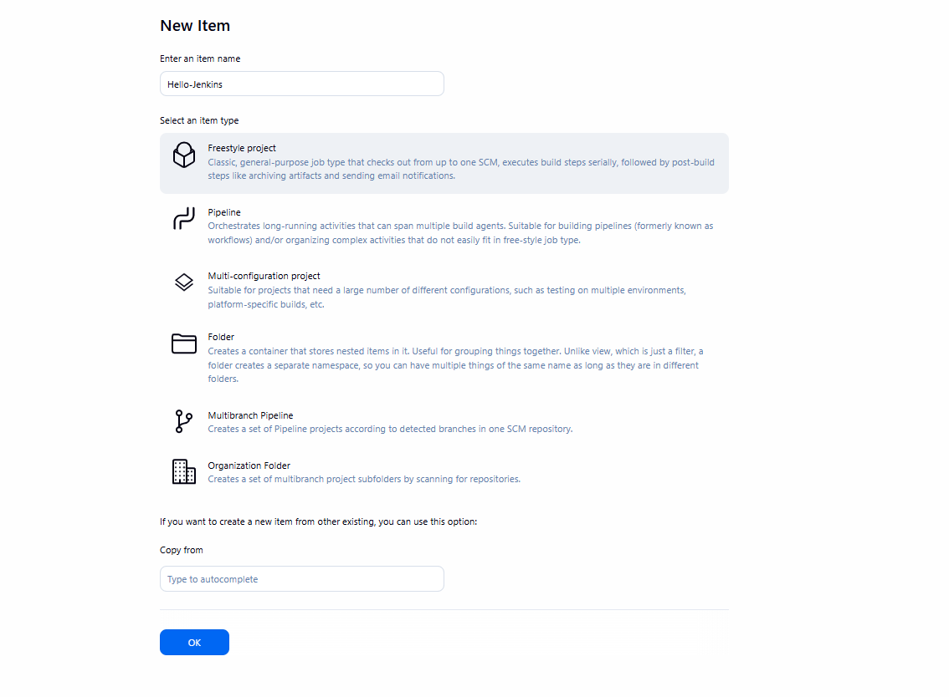
2. Add a description
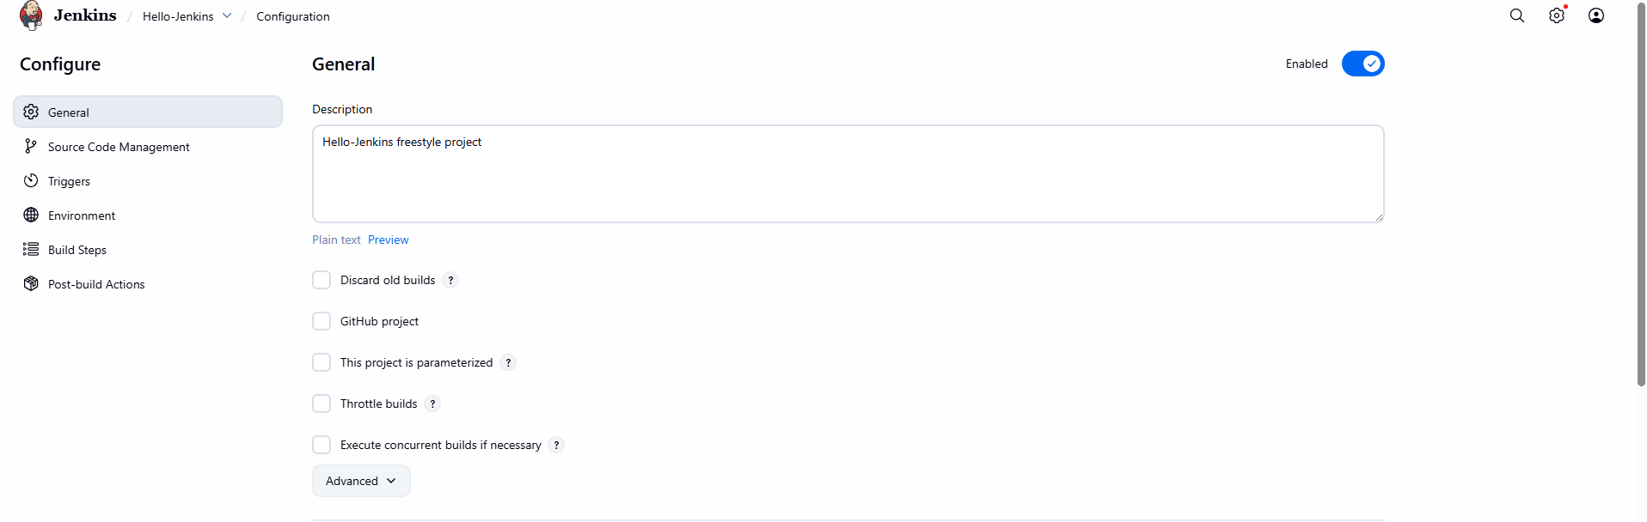

3. Add build step: o Execute shell / Windows batch command o Print "Hello Jenkins"
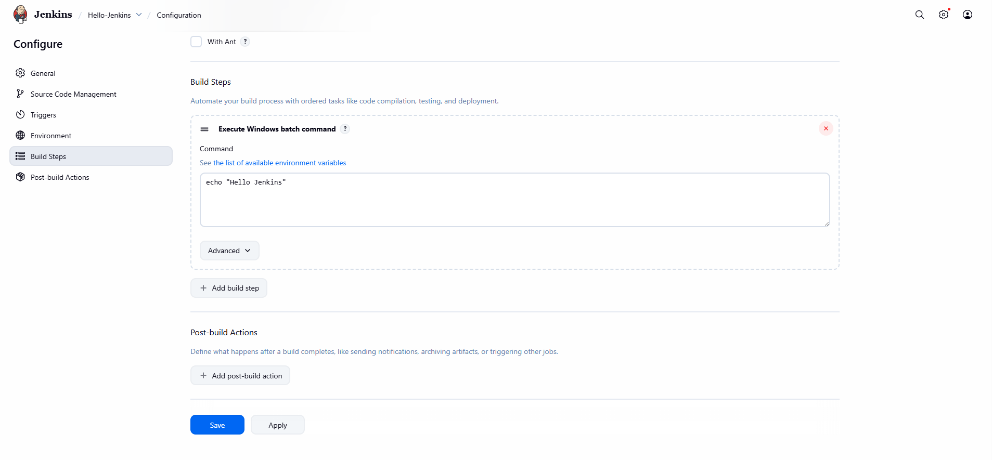

4. Build the job manually
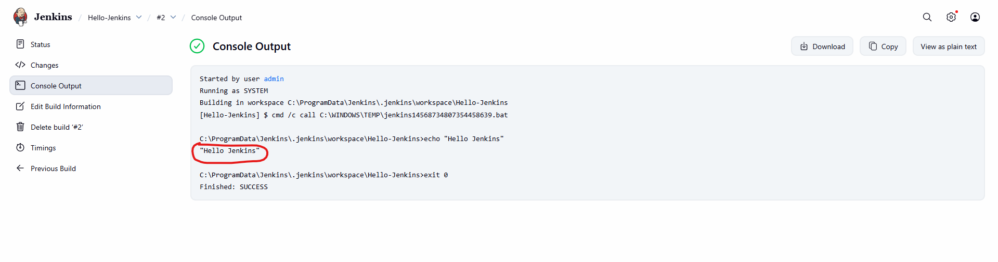
Expected Output: • Console output showing message

TASK 3: Jenkins Workspace & Commands
Objective: Understand workspace usage
Tasks:
1. Navigate to job workspace
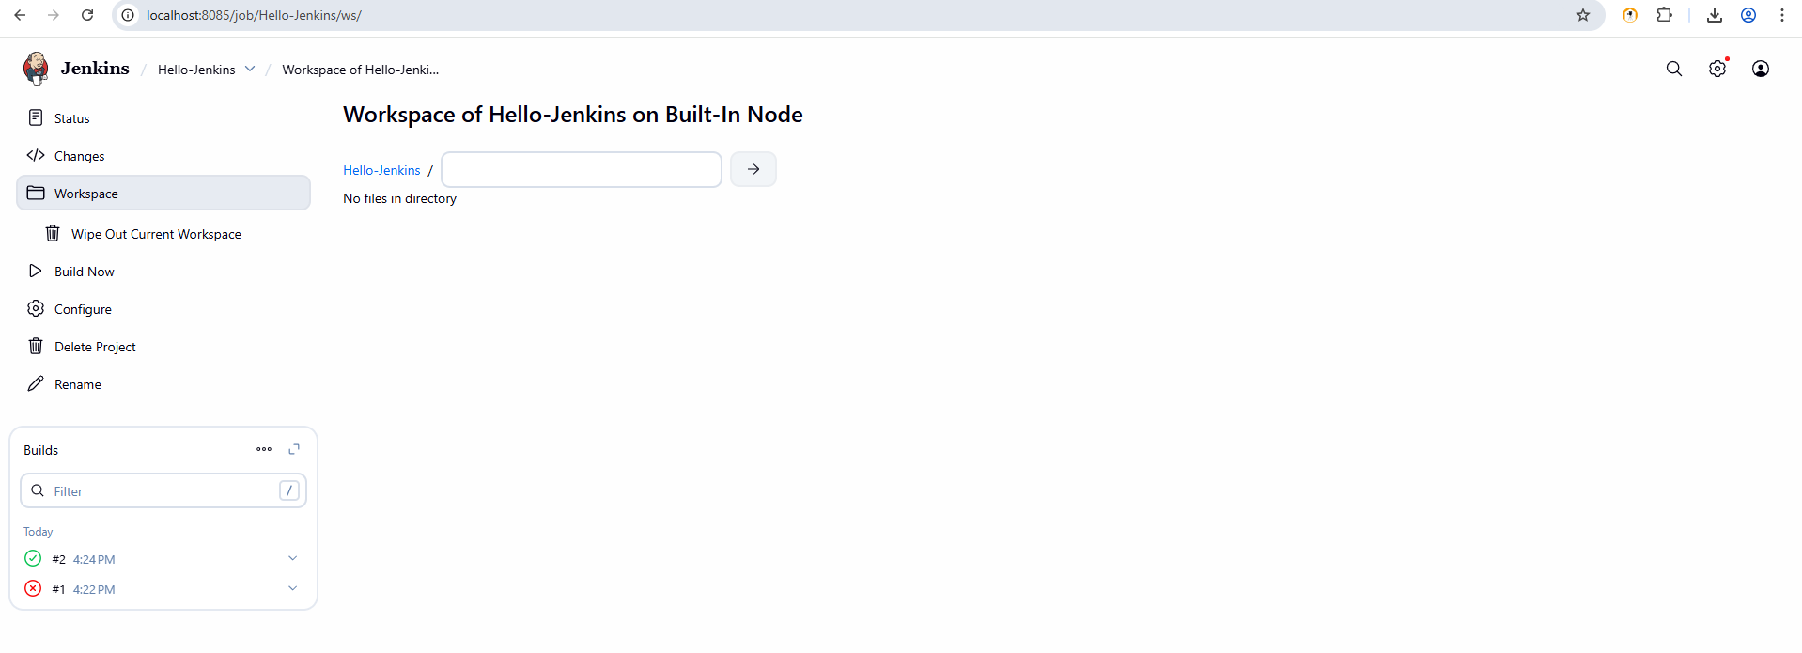
2. Create a text file using build step
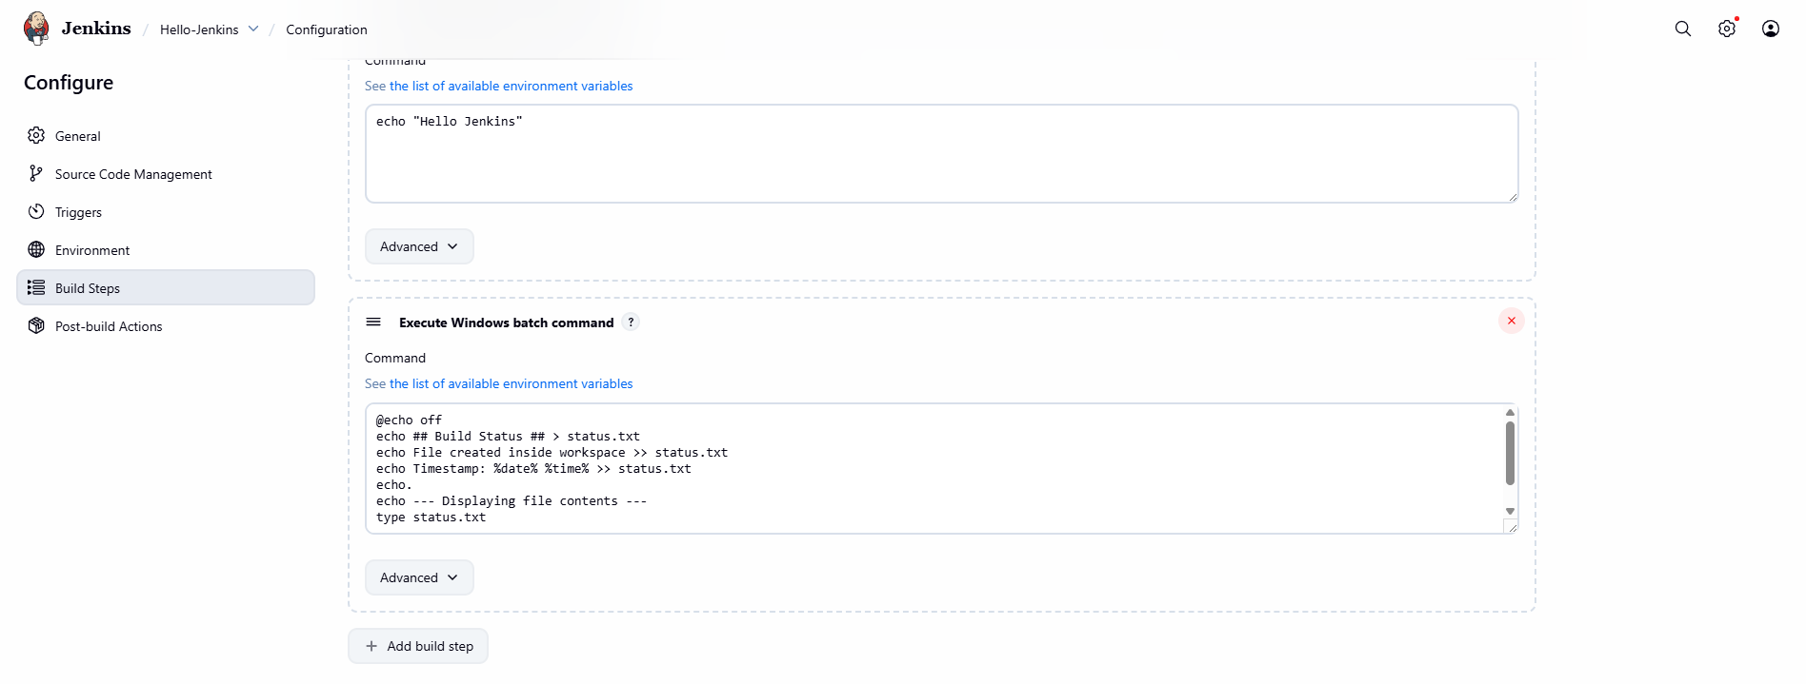
3. Display file contents in console
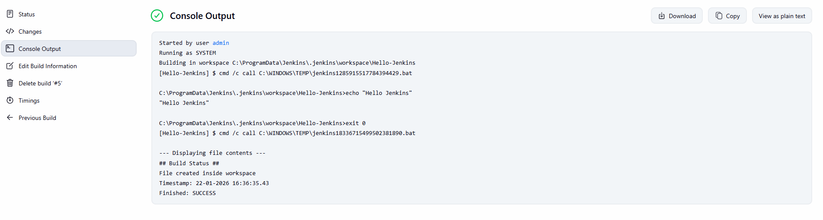
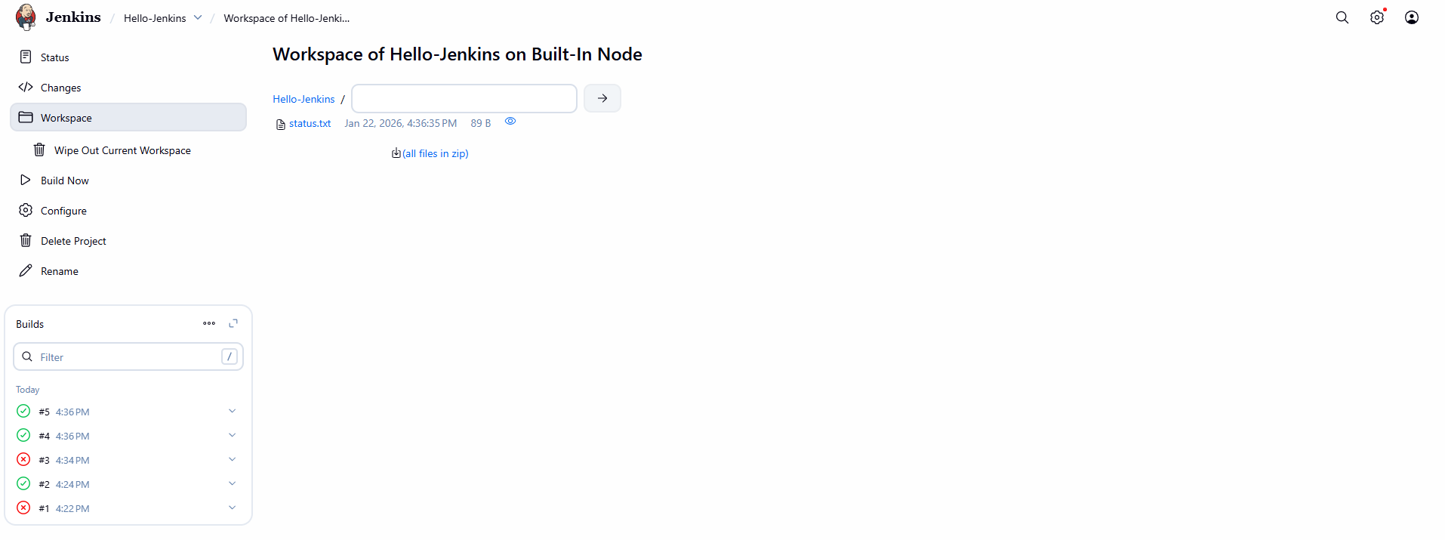

Expected Output: File created inside workspace

TASK 4: Git Integration
Objective: Integrate Jenkins with GitHub
Tasks: 1. Create a GitHub repository with sample code
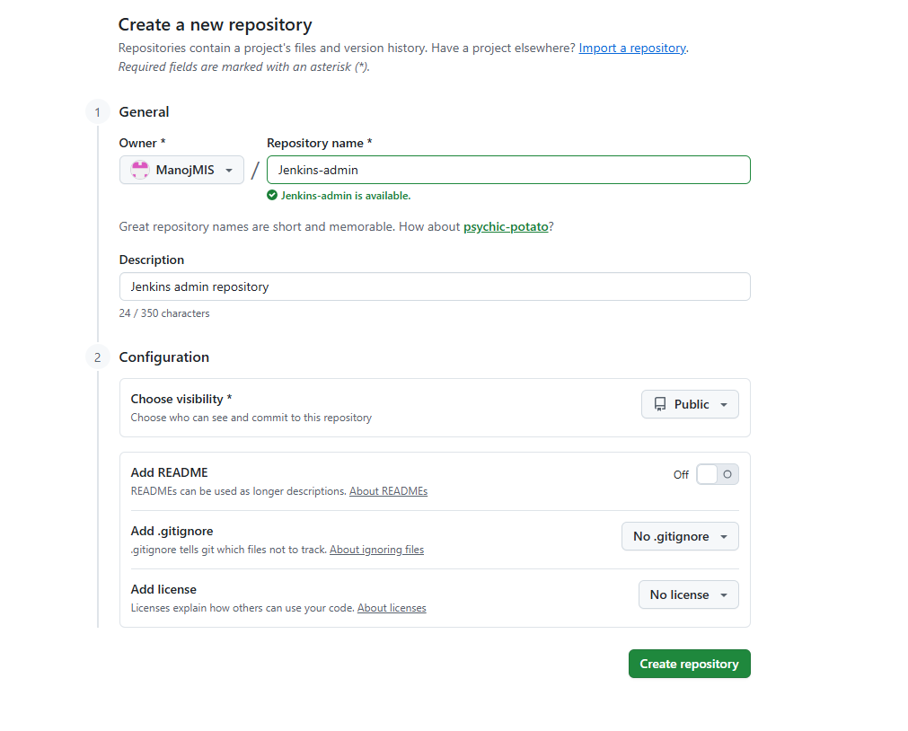
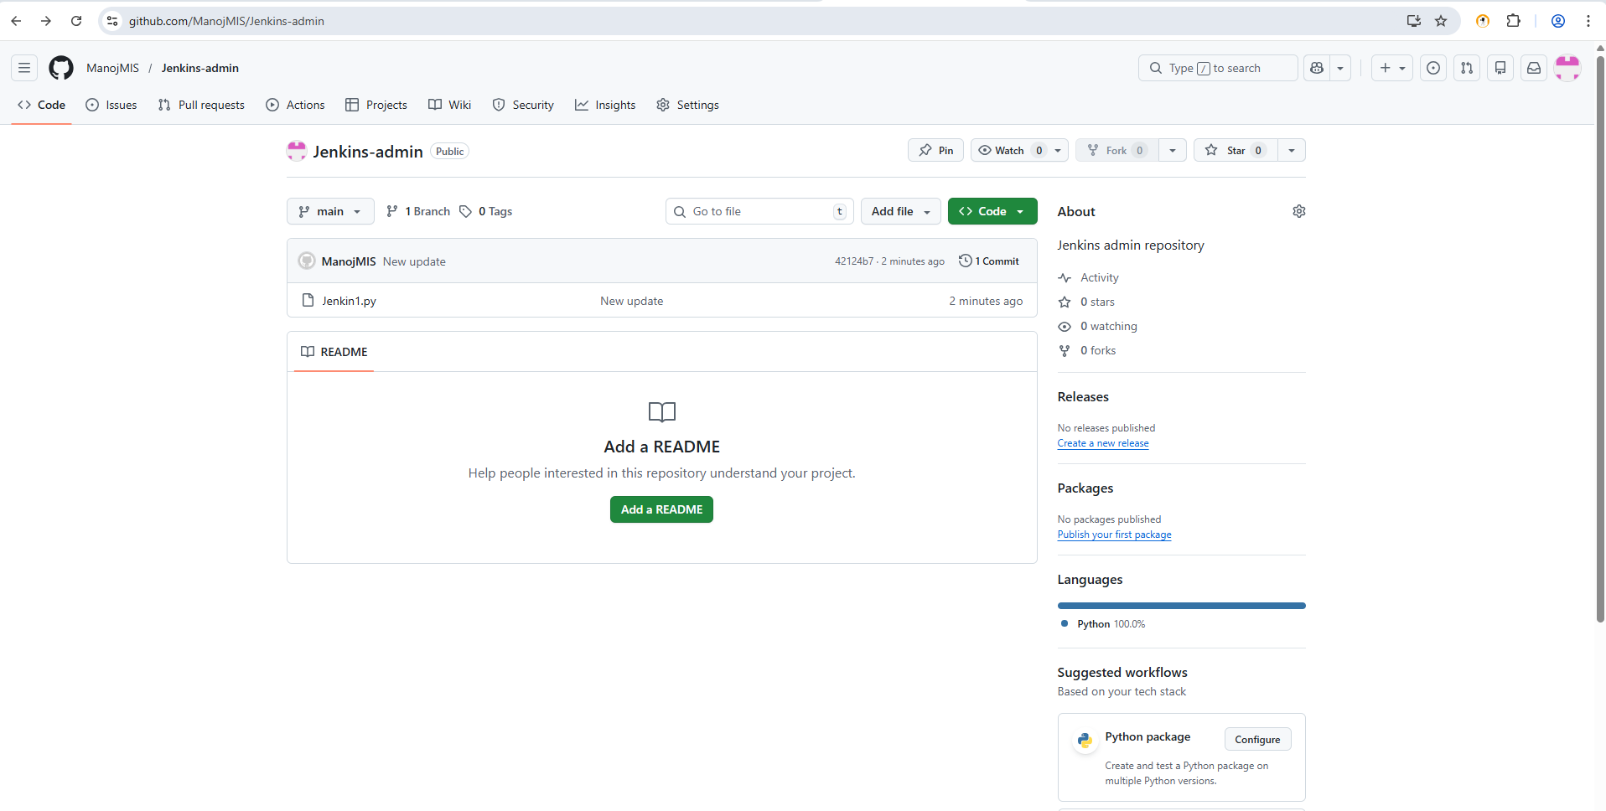

2. Configure Git in Jenkins
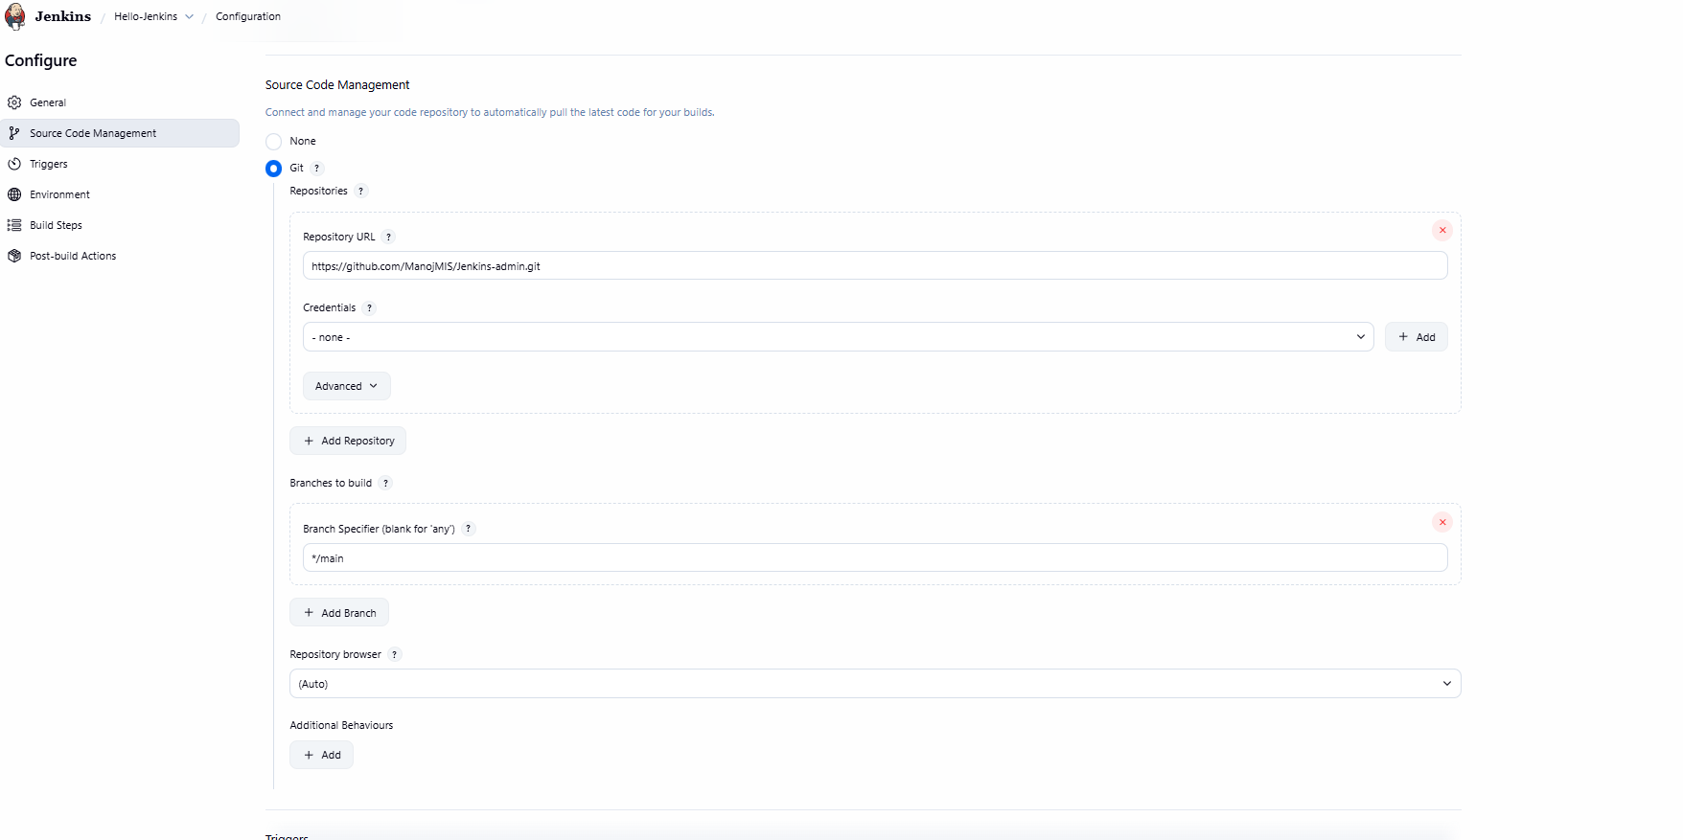
3. Add Git repository URL in job
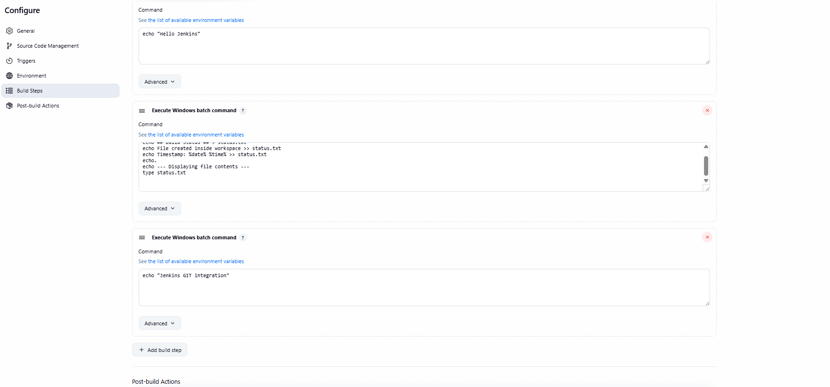

4. Build and verify code checkout
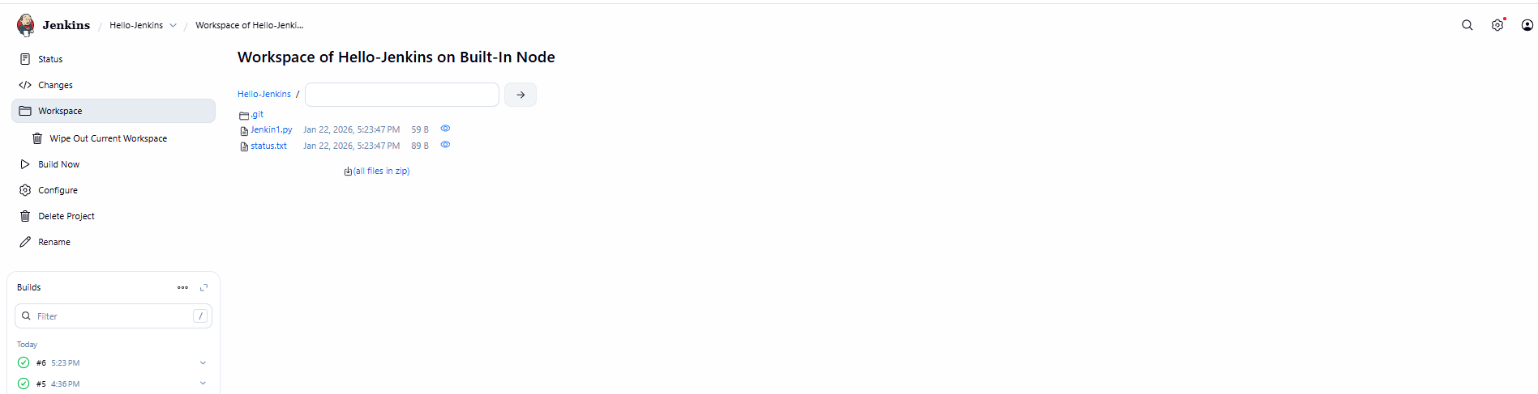
Expected Output: • Source code visible in workspace

